NSN Change Notification (formerly 148) User Guide

What is the NSN Change Notification facility?

On occasion, details on an NSN can change. When this occurs, ISIS generates a NSN Change Notification which is an output informing the user of the specific details of the change. This could be a characteristic change, a cancelled NSN, Item name change etc. (See table A).

Who has access?

The NSN Change Notification facility can be used by NCAGE account holders to view all NSN’s where their NCAGE is listed as the manufacturer or supplier of the item. In addition, manufacturers/design authorities can view the information related to these NSN’s, in particular any amendments made to the record. If customers have an ISIS Web account or an eTasking account, then a link can be provided through either of these to the NSN Change Notification facility.

What is the information used for?

For data consistency throughout the supply chain, manufacturers and suppliers of items should ensure that these changes are reflected in their own documentation and that users of the items are made aware of the change.

Using the Facility

Users should log into ISIS with their username and password. If you do not have a password, contact UKNCB Ops on 0141 224 2116 (existing etasking customers must request a link to the My NSN facility).

Go to NCAGE tab, choose My NSNs. (If this is not displayed, you will have to inform UKNCB to activate this facility on your behalf. To do so, please call 0141 224 2202).

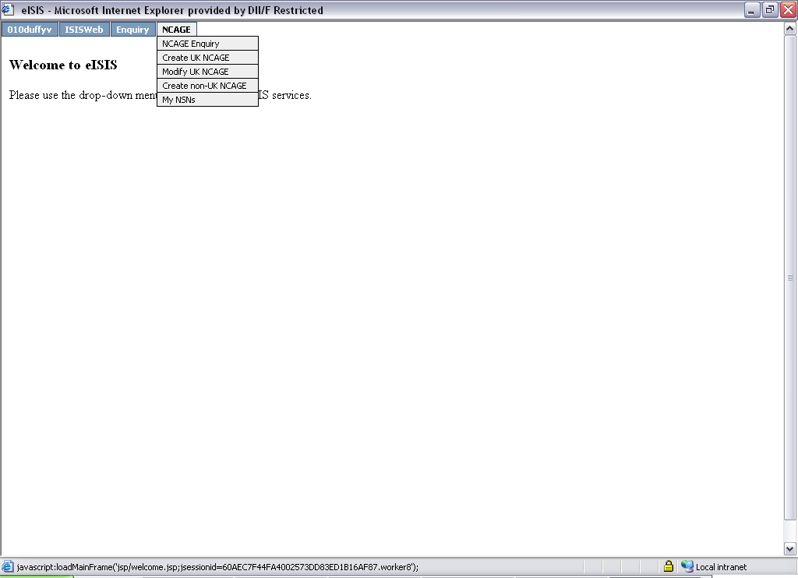

A list of applicable NSNs will be displayed showing the recorded reference and the item name.

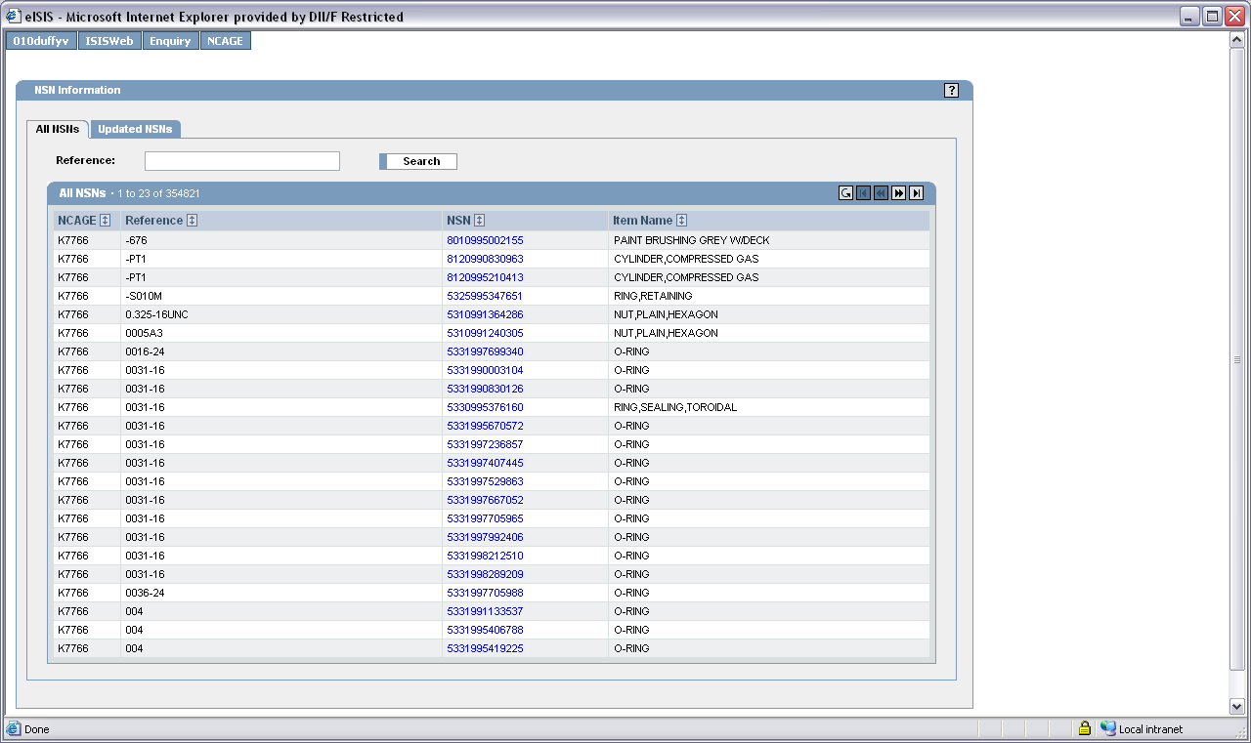

Manufacturers and design authorities only;

Manufacturers and design authorities for these items will be able to see further information on the ‘Updated NSN’s tab.

Choosing the ‘Updated NSN’s’ tab will filter the list to show those lines where an amendment has been made to the data. The reason for issue is also displayed.

Lines that have not yet been viewed will appear in bold. Click on the NSN you wish to view.

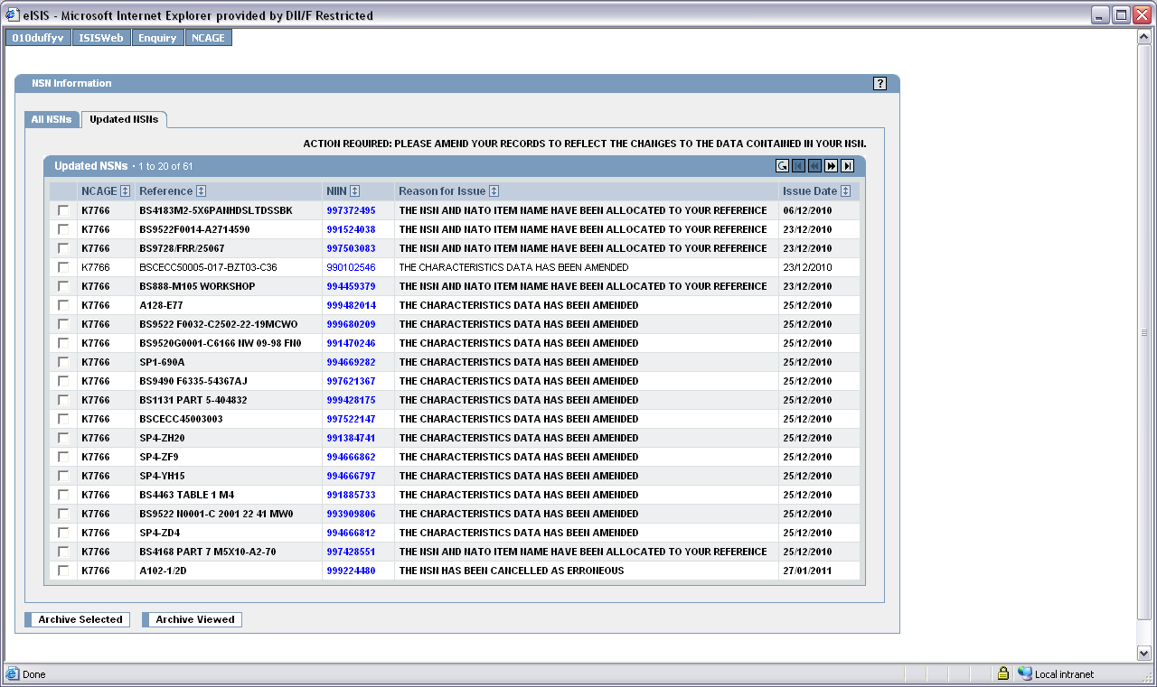

Selecting the NSN will display the Total Item Record. Amendments to data can be viewed here.

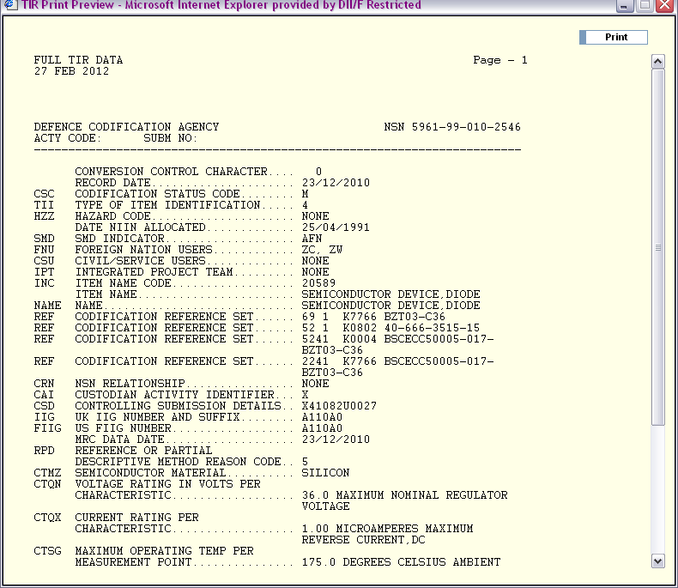

When returning to the list, the user has the choice to filter the list further to show only those that have not been viewed by selecting ‘Archive Viewed’.

Please note: It is the company’s responsibility to control who can archive items to ensure changes are actioned appropriately.

Or ticking the boxes at the left of the line entry, and selecting ‘Archive Selected’.

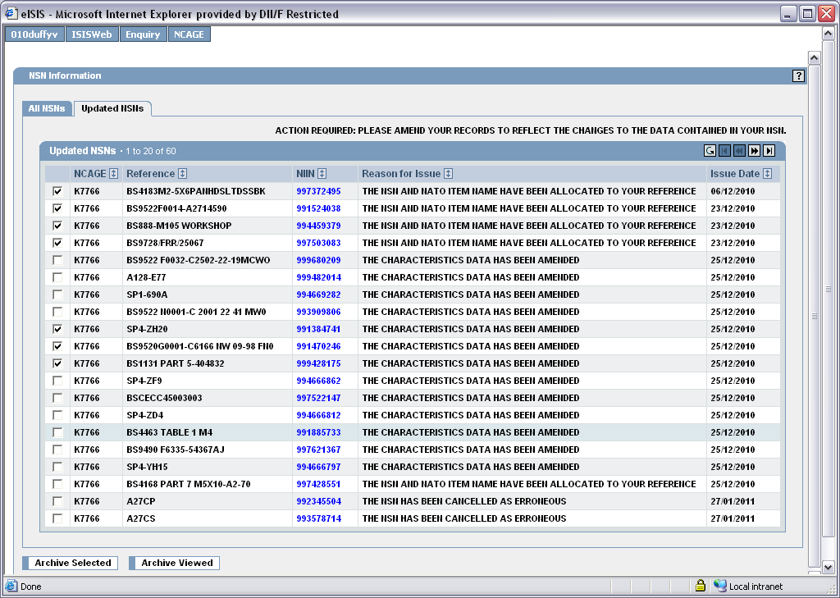

To view archived data choose the ‘All NSN’s tab and search by part number.

Table A

Action required

Reason for Issue | Action
THE NSN AND NATO ITEM NAME HAVE BEEN ALLOCATED TO YOUR REFERENCE | Update records, documentation, labelling with NSN.
THE REFERENCE HAS BEEN WITHDRAWN | Update records documentation, labelling to remove NSN. TBC
NATO ITEM NAME AND FIRST FOUR DIGITS OF THE NSN HAVE CHANGED | Update records, documentation/labelling with changed NSN.
THE NATO ITEM NAME HAS CHANGED | Update records, documentation/labelling with change.
THE FIRST FOUR DIGITS OF THE NSN HAVE BEEN CHANGED | Update records, documentation/labelling with changed NSC.
THE CHARACTERISTICS DATA HAS BEEN AMENDED | Take appropriate action according to change.
THE NSN HAS BEEN CANCELLED AS ERRONEOUS | Update records documentation, labelling to remove NSN. UKNCB must be contacted if NSN requires reinstatement.
THE NSN HAS BEEN CANCELLED | Update records documentation, labelling to remove cancelled NSN and substitute with replacement where appropriate.

